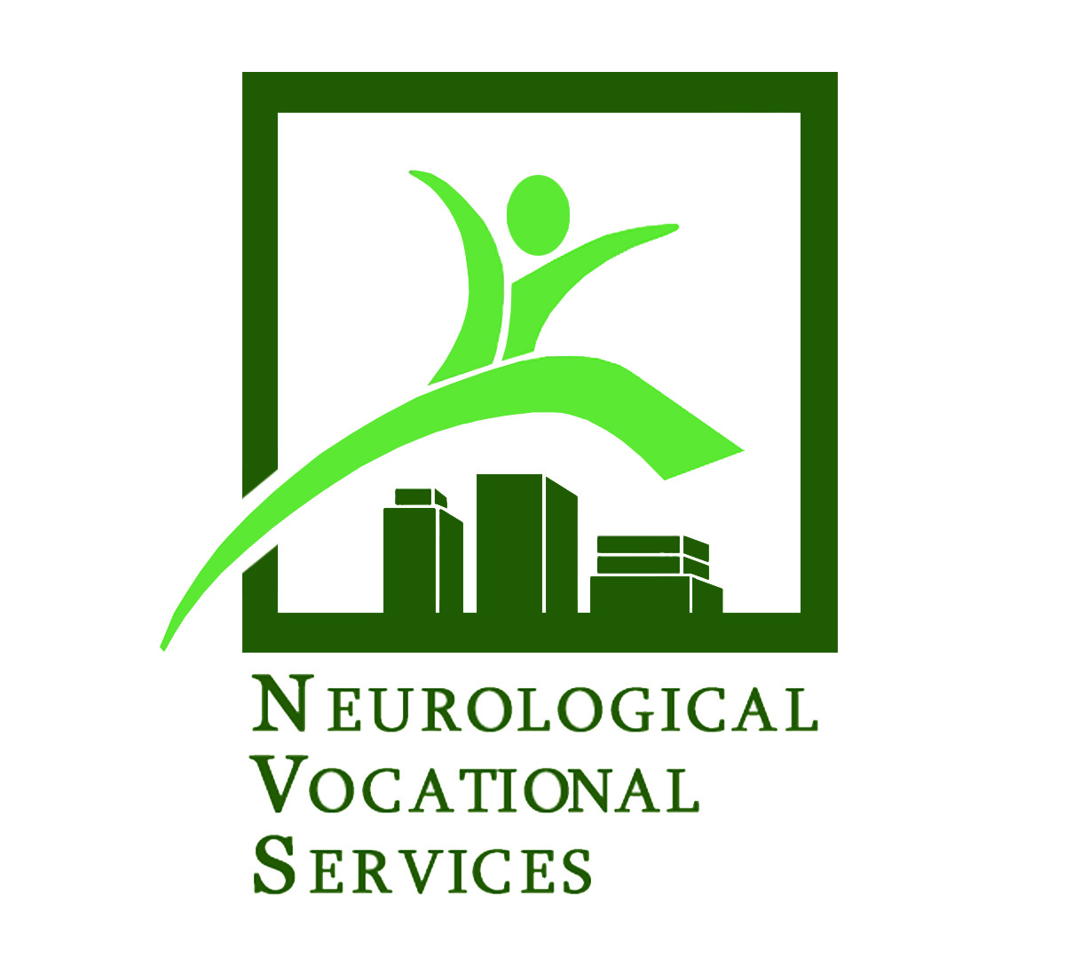
A BENEFIT AUCTION TO SUPPORT THE ONGOING WORK OF

NEUROLOGICAL VOCATIONAL SERVICES
Helping people with neurological conditions gain independence, one person, one job at a time.
SPRING FLING DONATION FORM

A U C T I O N D A T E : May 20, 2021

Donor Name As It Will Appear in the Catalog (please print legibly): Website

Contact Name for Arrangements Business Name (if applicable)

Day Contact Phone Contact E-mail Address

Mailing Address City State Zip

Check here if you are interested in becoming a Gala Sponsor: (We will contact you with further details.)

DONATION DESCRIPTION (please attach any additional information):

Please be complete (i.e., quantity, size, color, number of people, valid dates, all label information for wines, etc.):

Thank you for your Generous Donation
RESTRICTIONS (expiration date if any, date specific, alcohol and/or tax & gratuity not included, etc.):
DONOR STATED VALUE:

$

Donor Signature (required): ________________________________________________ Date: ___________________________________

Name of Procurement Rep: _________________________________________________ Day Phone: ______________________________
(Please print legibly)

Neurological Vocational Services - a 501(c)(3) Non-Profit / Federal Tax ID: # 91-1412467

Harborview Medical Center - Box 359744 / 325 9th Ave - Seattle, WA USA 98104 Tel: 206.744.9130 FAX: 206.744.9988 Website: www.nvsrehab.org
Contact: Robert Fraser, Ph.D., Executive Director Tel: 206.744.9131 E-mail: rfraser@uw.edu; epawley@uw.edu

